**MPPT**

**What is MPPT?**

MPPT follows the peak value of the power obtained in certain periods and sends it to the load in DC-DC inverters. The regulator will work out at which point the cell will output the maximum power and derive from this the voltage and current outputs required for maximum power to be achieved.

**Some core specifactions about MPPT26, 17**

* 12 V or 24V battery output
* 20 A peak charging current
* 55 V max PV (photovoltaic)
* 32 bit MCU (in our project STM32)
* CAN communication interface with standard RJ45 jacks

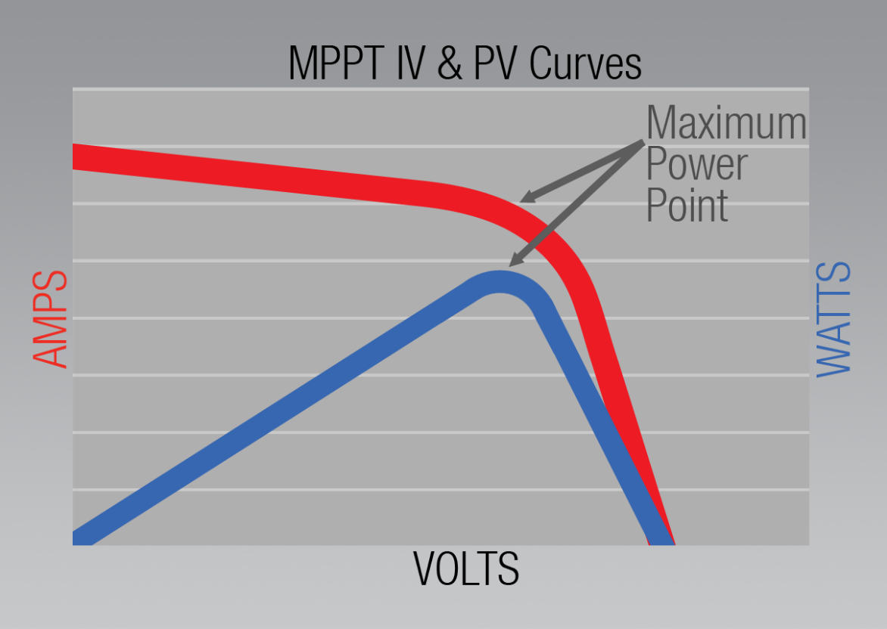

Fig. 46 MPPT Graphs

**MPPT ALGORITHM**

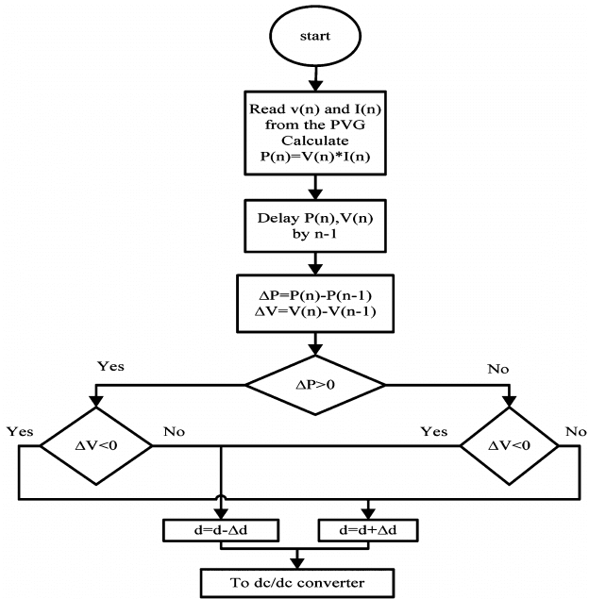

Fig. 47 MPPT Algorithms

To arrange the maximum power point, MPPT has an algorithm inside of it. MPPT tries to find maximum power point with changing the duty.

Logic in this algortihm is simple; we want to reach maximum power and to reach that we should check delta power first. After that we should look for voltage value to understand what we should do with duty cycle (Vo=Vs x D).

If delta power (power difference) is bigger than 0 which also means if change on power is positive, then we will look for delta voltage. If delta voltage is smaller than 0, that means we should increase the duty which is shown as d.

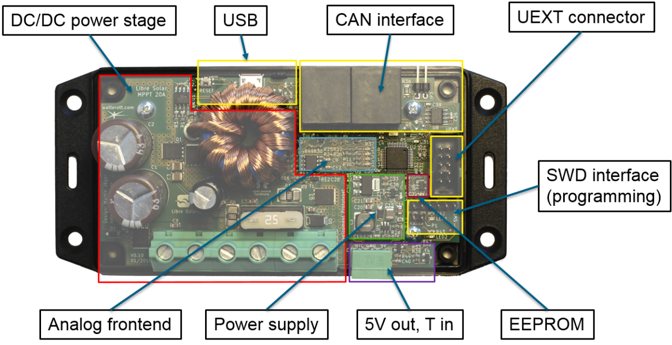

Fig. 48 Parts of MPPT

**Parts of MPPT**

**EEPROM**

It means electrically erasable programmable read-only memory.

**UEXT Connector**

Universal EXTension (UEXT) is a connector layout which includes power and three serial buses: Asynchronous, I2C, and SPI.

**CAN Interface**

CAN (Controller Area Network), CANopen’ın fiziksel katmanını oluşturan ve otomotiv otomasyonunda kullanılmak üzere Bosch firması tarafından geliştirilen bir seri ağ teknolojisidir

CAN is a half duplex high speed network system with double twisted cables. It meets many needs, including real-time communication between microcontrollers.

**SWD Interface**

Serial wire debug is an ARM-specific protocol specifically designed for micro debugging.

**DC/DC Power Stage**

DC/DC converters are used in applications where an average output voltage is required, which can be higher or lower than the input voltage.

The converter presents an electrical load to the solar panel that varies as the output voltage of the converter varies. This load variation in turn causes a change in the operating point (current and voltage characteristics) of the panel. Thus by intelligently controlling the operation of the DC-DC converter, the power output of the panel can be intelligently controlled and made to output the maximum possible.

There are 3 types of DC-DC converter;

1. **Buck-Boost Converters (bidirectional)**

Buck / boost converters are an inverting DC-DC converter, that is, it converts the alternans of the input voltage to reverse polarity. While the positive end is on the upper side at the input, the polarity of the voltage has changed by passing to the lower side at the output.

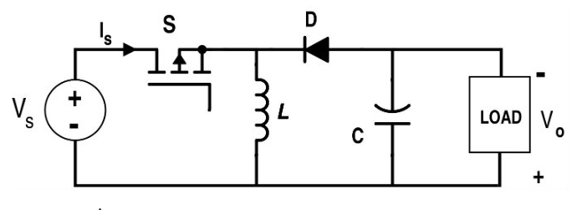

Fig. 49 Buck-Boost Converter Circuit

Like boost converters, there are 2 modes:

* **Closed Switch**
* **Open Switch**

**Closed Switch**

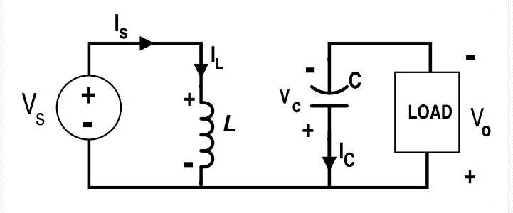

Fig. 50 Closed Switch

The coil in the circuit is energized by the energy coming from the source. On the right, the energy on the capacitor is transferred to the load. In this case, D diode in the circuit is cut. Since the average voltage of the coil and the average current of the capacitor are zero in direct current circuits, the voltage of the coil will be reversely induced in the other (when the switch is cut) in the circuit and the current of the capacitor will flow in the opposite direction.

**Open Switch**

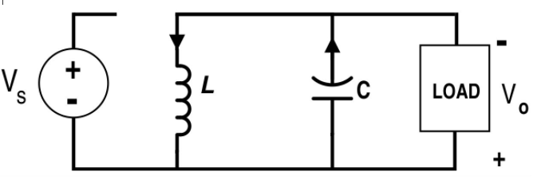

Fig. 51 Open Switch

In the previous case, the coil energized through the input source discharges its energy on C and load. The capacitor, which transferred its energy to the load in the previous case (Switch transmission), is re-energized with the energy coming from the coil in the second case. The circuit diagram of the second situation, in which the switching element is cut, is given in the following figure. In this case, since the input source will be completely disconnected from the circuit, the circuit is fed through the coil. In the circuit below, current flows through the D diode until the coil is de-energized, and the capacitor is fed with this current.

*Here its what i find on libre solar site; **‘As a synchronous buck converter, the DC-DC power stage can be changed into a boost converter by software. In this case, current flow goes from the battery output to the solar input. This feature can be used to charge an electric bike battery pack with 36V nominal voltage using a 12V solar pannel. Sounds strange, but works and has been tested already. The 5V output is needed to switch on the bicycle battery (e.g. Bosch or Specialized).’**

1. **Boost Converter (Step Up)**

Boost Converters are using for increasing the voltage to wanted value. These converters works with 2 mode which are open and closed switch.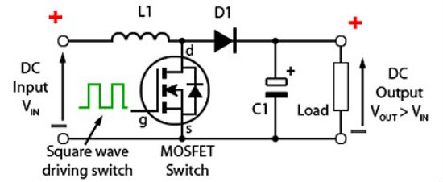

Fig. 52 Boost Converter

The difference is obtained between the value obtained from the output of the circuit and the desired voltage value at the output. This difference obtained is compared with the wave obtained in the triangular wave generator. If the result of the comparison is greater than the difference between the desired value and the actual value, the switching element in the circuit is triggered. If the current value of the triangle wave signal is less than the Vcontrol value, the input end of the switching element in the circuit is reset and its trigger is cut.

**Open Switch**

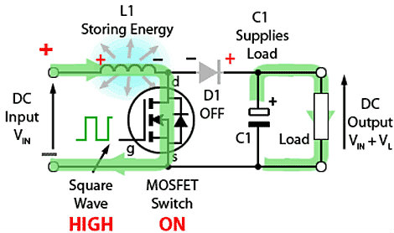

Fig. 53 Open Switch

**Closed Switch**

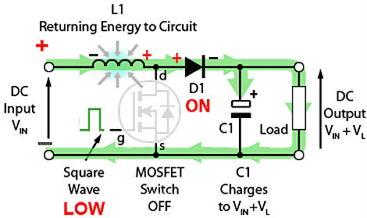

Fig. 54 Closed Switch

Since the current on the coil can be unidirectional in boost converter circuits, the voltage between the ends of the coil is induced in two different polarities between the two modes. Since the voltage of the capacitor cannot be reverse induced in this circuit due to the nature of the capacitor, the current flows in two different directions through the capacitor in two modes. Thus, the average voltage of the coil and the average current of the capacitor become zero in the circuit.

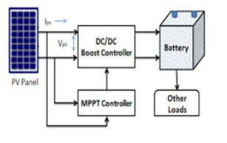

Fig. 55 PV schematic

Block diagram of how MPPT stays in PV schematic.

1. **Buck Converters (Step Down)**

We need Buck Converters because of reducing the loses and voltages.

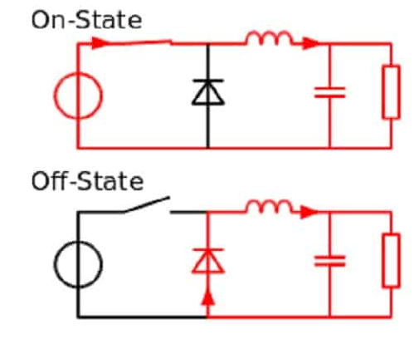

Fig. 56 On and Off State

Main schematic of Buck Converters is in near. Mosfet is generally used as circuit switch here. The reason why it is preferred over BJT is that the mosfet in power electronics causes **less power loss2.**

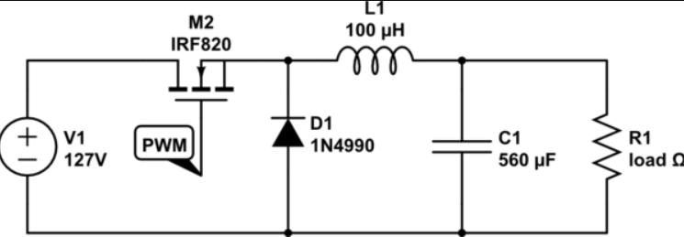

Fig. 57 Buck Converter Circuit

With the Mosfet PWM, it will transfer some of the power from the battery / voltage source to the Load, with 100 times of opening and closing per second. But when we did this, we added **capacitor** because Load would be nonfunctional at 0 V. Thus, the capacitor will be charged together with the MOSFET and will discharge its energy when the MOSFET is turned on, so the load will not be 0 V. However, in this case, since the capacitor cannot change the voltage instantly, we added **inductance** instead of resistance. However, while Mosfet is opening, the inductane tries to prevent Mosfet because the current cannot change instantaneously. We have added **diodes** in it. Thus, the current is always circulating.

**Buck Converter Formulas**

**Analysis for the Switch Closed**

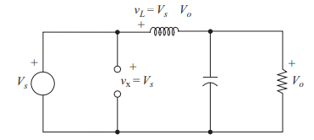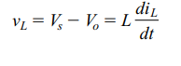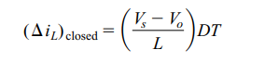

Fig. 58 Closed Switch

**Analysis for the Switch Open**

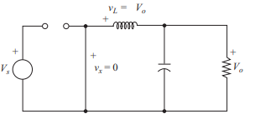 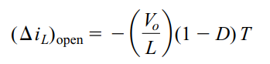

Fig. 59 Open Switch

**General Formulas of Buck Converter24**

One of the main formulas:



To find Imax an Imin we already know change in inductor current.

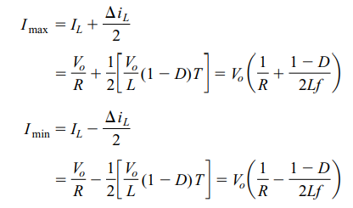

If the desired switching frequency is established;

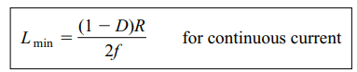

The value of inductance for a specified peak-to-peak inductor current for continuous-current operation:

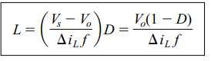

Output Ripple Voltage:

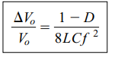

**To make easier we put these formulas on excel file.** So when we need to change the values we will not have to be calculate everything.

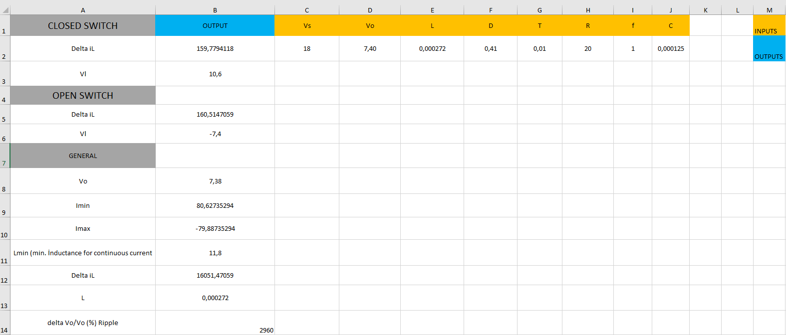

Fig. 60 Our excel table of formulas

Some values can look wrong (output ripple) this is because we did not enter all the values (frequency).

**PSPICE DESIGNING OF OUR OUR BUCK CONVERTER**

We used MOSFET instead of diode because MOSFET has more efficieny than diode. Also it has diode inside of it so it will work us. We need to reduce 18.3 V (Panel Output Voltage) to 7.4V(Nominal Charge Voltage of Battery) thats why we need to use step down (Buck Converter).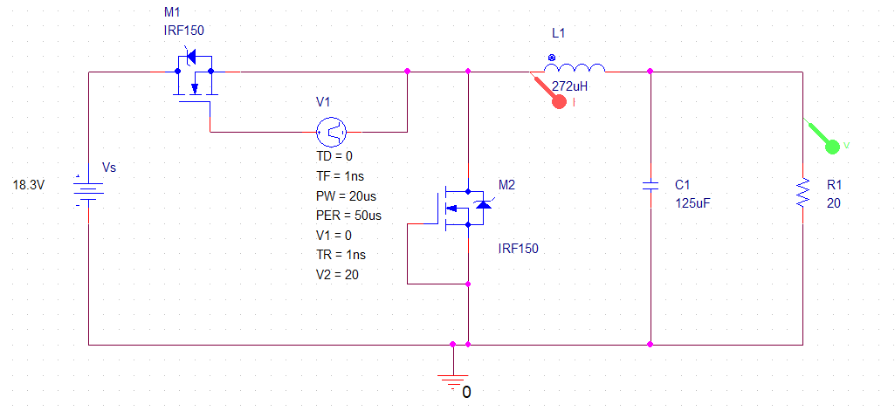

Fig. 61 Buck circuit design of our system

**Our Simulation Results**

Fig. 62 Voltage and Amps. Result (higher one is voltage)

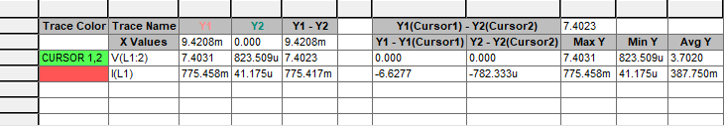

Fig. 63 Table of result

**Solar Panel**

We need energy to work with circuits and we thought that solar panel are the most suitable one to use. The biggest reasons for choosing solar energy are;

-The most potential energy production method to be used in the future

-It is a renewable energy method

-Solar energy (UAVs) can access any locations. That is why it has more efficieny.

**How we choose the Solar Panel?**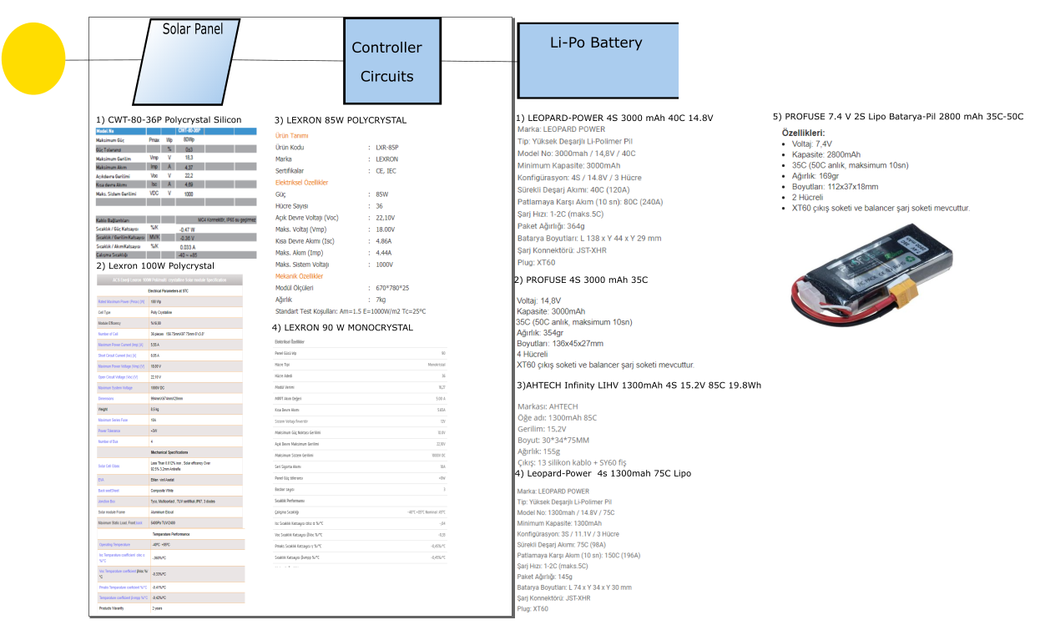

Fig.64 Solar Charger Chart

**Types of Solar Panels**

There are three types of solar panels to choose so first lets look for them25.

1. **Thin-film Solar Panels**

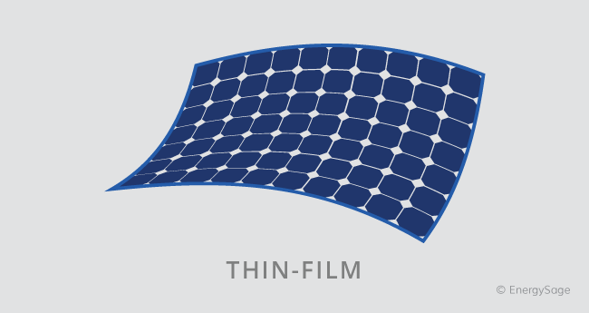Not at all like monocrystalline and polycrystalline sun-powered boards, thin-film boards are made from an assortment of materials. The foremost predominant sort of thin-film sun based board is made from cadmium telluride (CdTe).

Fig. 65 Thin -film

Biggest *disadvantage* of thin-film panels is they have *lower effiency* than other panels (11%). Also they are tend to corruption faster.

**2- Monocrystalline Solar Panels**

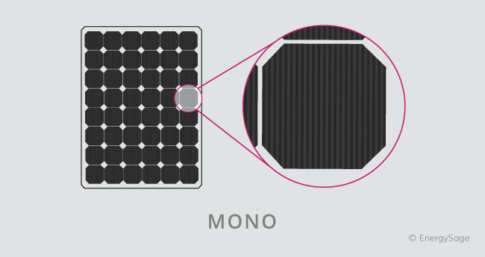Monocrystalline solar cells are cut from a single crystal of silicon.

Of all panel types, monocrystalline typically have the highest efficiencies and power capacity. Monocrystalline solar panels can reach efficiencies higher than 20 percent. They have come in higher wattage modules so that means they can generate more power. However they are most expensive type of solar panel.

Fig. 66 Monocrystalline

1. 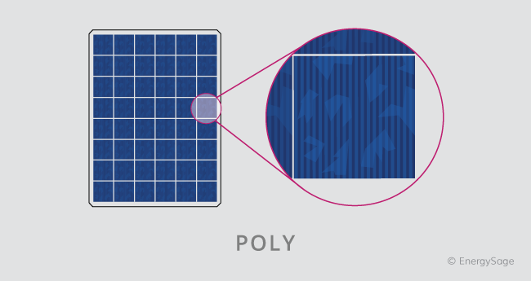**Polycrystalline Solar Panels**

Fig. 67 Polycrystalline

Polycrystalline solar cells are composed of fragments of silicon crystals that are melted together in a mold before being cut into wafers.

Polycrystalline solar panels usually have efficiencies between 15 to 17 percent. Polycrystalline solar panels are typically cheaper than monocrystalline solar panels. This is because the cells are produced from silicon fragments rather than a single, pure silicon crystal.

When we think of pros and cons, we decided to choose polocrystalline solar panels because + plus efficiency is not worth the extra cost for monocrystalline solar panels.

Then we have two option to choose:

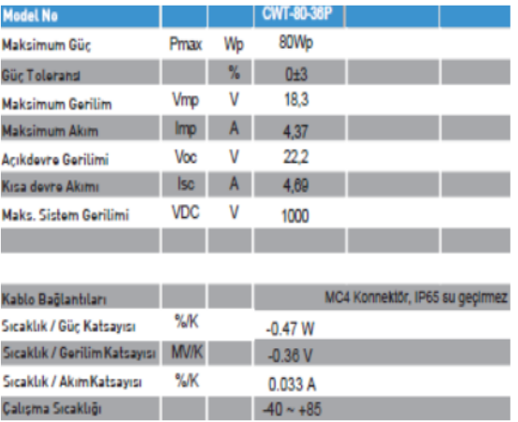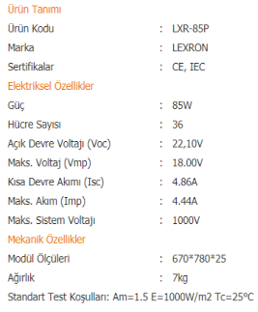

Fig. 68 Lexron 85 W Fig. 69 CWT 80 W

**These are similar to each other. Lets look our calculations for CWT-80-36P.**

As we know, power can change depends to temperature and these panels are tested for 25° C. But what if the temperature is not 25 °C? Then we have to use this formula:

**80 W- (T-25 C) *0.47 W**= Power that we have in our T (temperature)3.

As we can see, there are more coefficients like voltage coefficient and current coefficient which depend on temperature. These also can be calculated with the same logic.

**Another calculation for panel is coming from battery.**

To understand our panel power is enough, we have to calculate the batteries power.

We know that, **our battery** has these datas:

11.1 V and we need 3.4 A to charge battery

So, 11.1x3.4= **37.74** W

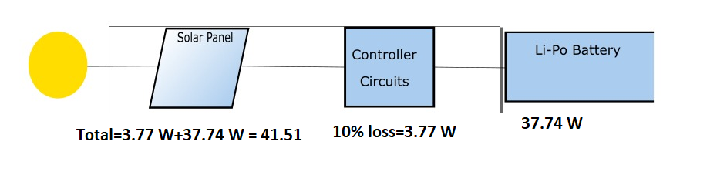

Fig. 70 Chart of Total Power

Also when we think about the loss on controller circuits as 10% (37.74*0.1=3.77W) and when we add to required power, we will reach the total power that we need which is 39.40tW (3.77W+37.74W). Easy to see that with considering the temperature our panels have enough power.

**MPPT Components Selection and Charger Calculations**

**Component’s Selections**

**Our Circuit:**

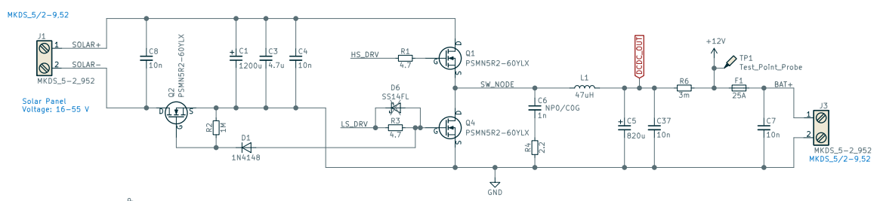

Fig. 71 MPPT Circuit

**The data that we already have:**

**Vin = 18V, Voltage that is produced by solar panel,**

**Vout = 12V, this is the needed output voltage for 3S li-po battery,**

**D = 0.66, Duty Cycle is ,**

**fs = 50 kHz, switching frequency,**

**L = 47 uH,**

**Pout = 100 W, this is the power capacity that can be produced by our solar panel,**

**Iout = 8.33 A, We can find this with P=V*I. (100 W = 12 V * Iout)**

To select the proper components we will need to find inductor ripple current:

Inductor Ripple Current





Also there is another situation; when the battery discharge, we will see lower Vo values like **9.5 V**.

Accordingly, if we calculate for also this situation:



Capacitor Voltage Ripple





Inductor Selection

We used that formula to pick the proper inductor for our circuit.





Inductor current ripple will be calculated with ripple percentage (in this case, it is assumed between 20% and 40%)



**In our project it is found as 20 %:**



Again for the discharging (9.5V) the percantage will be :



Output Capacitor Selection

With that formula, we will choose our capacitor.





**Steady-State Analysis [24]**

The buck converter is a means of reducing the dc voltage. The switch produces a rectangular waveform vs(t) as illustrated. 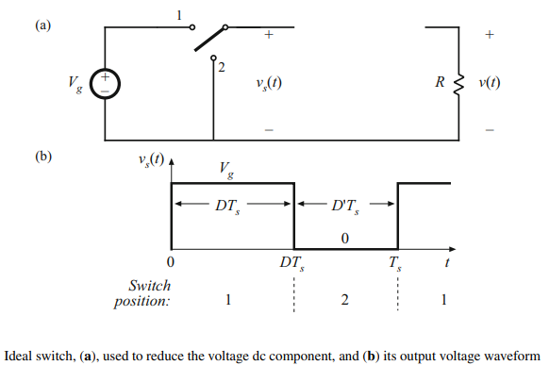

Fig.72 [24]

From Fourier we know that :

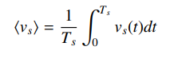

From the graph, we can evaluate that as :

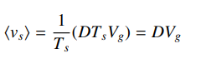

Hence, the output voltage is essentially equal to the dc component of vs(t):



**In our project:**

12 V = 0.66 * 18 V

Making a perfect low-pass filter that only passes the DC components is impossible. Thus, our low-pass filter allows the least some small amount of the high-frequency harmonics generated by the switch to reach the output.

This is why our output voltage waveform and formula will have the **ripple** voltage, so it will look like this:



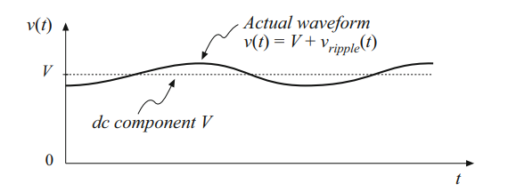

Fig. 73 [24]

There is two condution for the buck converter. 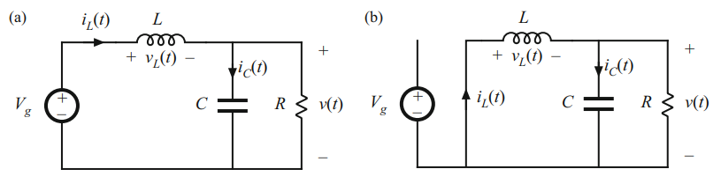

Fig. 74 [24]



First, let's look for an inductor for switch position 1.



We can neglect the ripple as its too small so we can rewrite this equation as:



**In our project:**

VL = 18-12 = 6 V

We know that:



Hence, the slope of the inductor current waveform will be:



The graph will look like this:

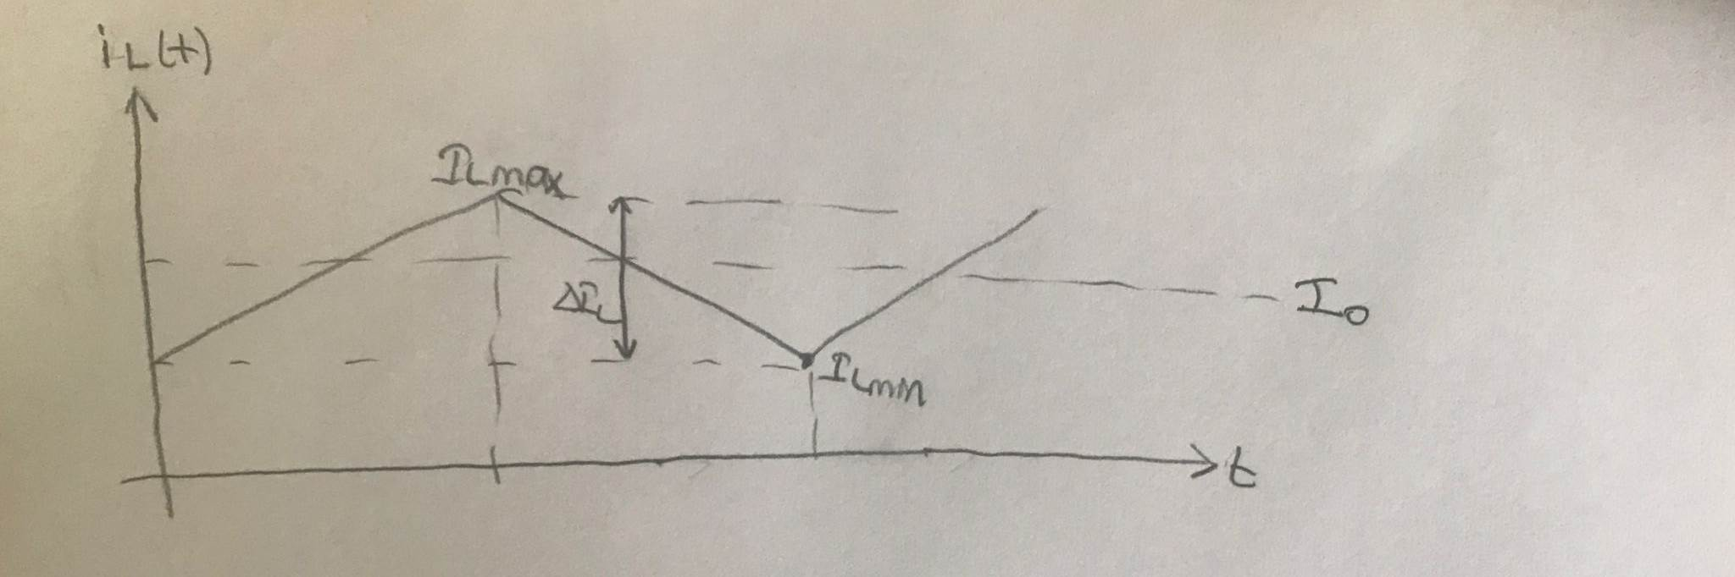

Fig. 75 Graph

For the switch is in position 2, our inductor will equations:



And so,

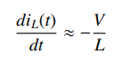

And the voltage-current waveform will be:

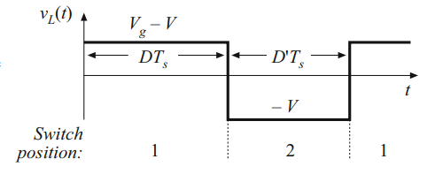

Fig. 76 [24]

The total graph of inductor current waveform will be:

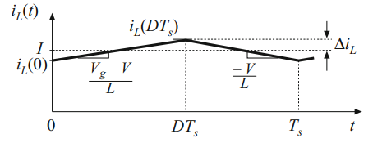

Fig. 77 [24]

When we looked at the ripple with these two positions for inductor; the formula is changed in current İL is equal to slope times length of the first interval (DTs) :

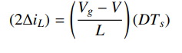

**In our project:**



**Inductor volt-second balance**

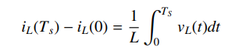

Change in inductor current is zero so:

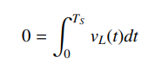

**Plant Transfer Function of Buck Converter 24**



 **(I)**



 **(II)**

from here we get with differential

 **(III)**

Let’s put (**III**) into (**I**):



Laplace: 

Then when we collect the transfer function on one side; we have the plant transfer function:



**In our project:**



**Bode Diagram of Transfer Function**

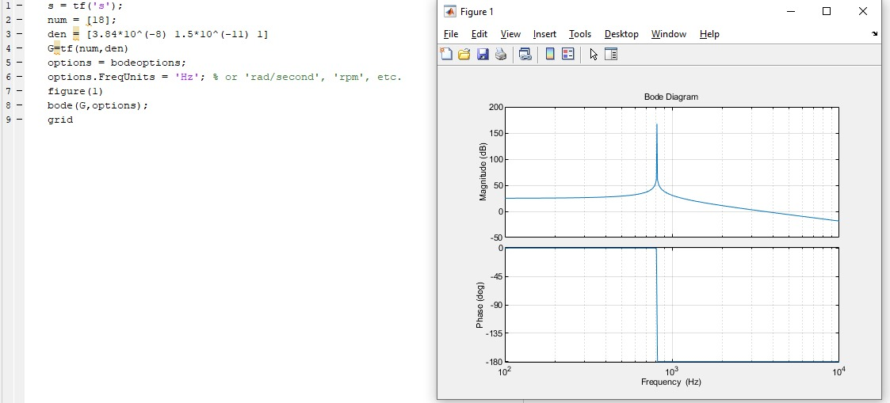

Our numerator was s0(18)

Denominator is calculated from coefficents of s0,s1 and s2.

Demonitor of Plant T.F. = 

Demonitor of Plant T.F = **s2(3.84*10-8) + s1(1.5*10-11) + s0(1)**

**ALTIUM DESIGNER**

While designing the charger controller circuit in our project, we used Altium Designer, a program that offers PCB design with an integrated design interface.

Altium Designer is a PCB and electronics design automation software package for printed circuit boards. Starting from very simple designs, many designs such as flex circuits can be realized with Altium Designer. With the help of Altium Designer, we can see how the circuits we designed with the 3D view will look. The basic features of Altium Designer are schematic design and PCB design

Considering these basic features, we decided to design the charger controller circuit with Altium Designer.

We first determined the components we will use in our circuit and adjusted them according to our own scheme. We created a BOM list. Then, according to the properties of the required materials, we looked at sites such as Digi-key and mouser and uploaded them to the Altium Designer program with their manufacturing part numbers. We created the schematic and footprint libraries. While creating the footprint of the components, we created it by paying attention to the data sheets given for the components. We also found 3D models of components from sites like 3D Content Central and Grabcad.

**Schematic Part:**

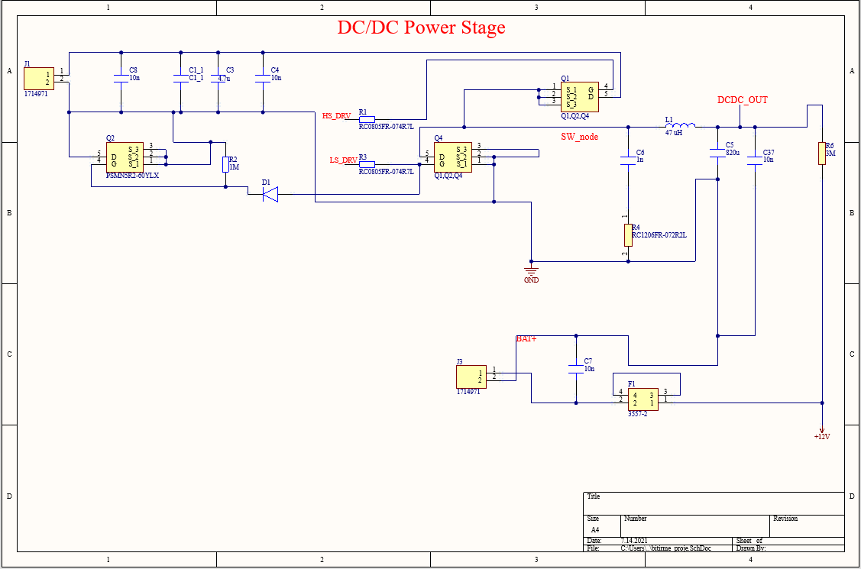

Figure 78:DC/DC Power Stage Schematic

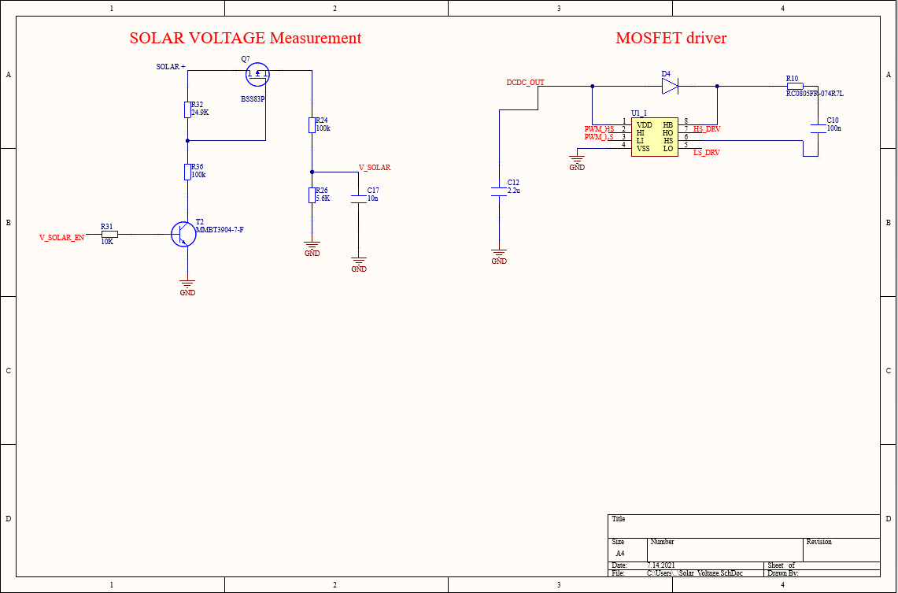

Figure 79: Solar Voltage Measurement and Mosfet Driver Schematic

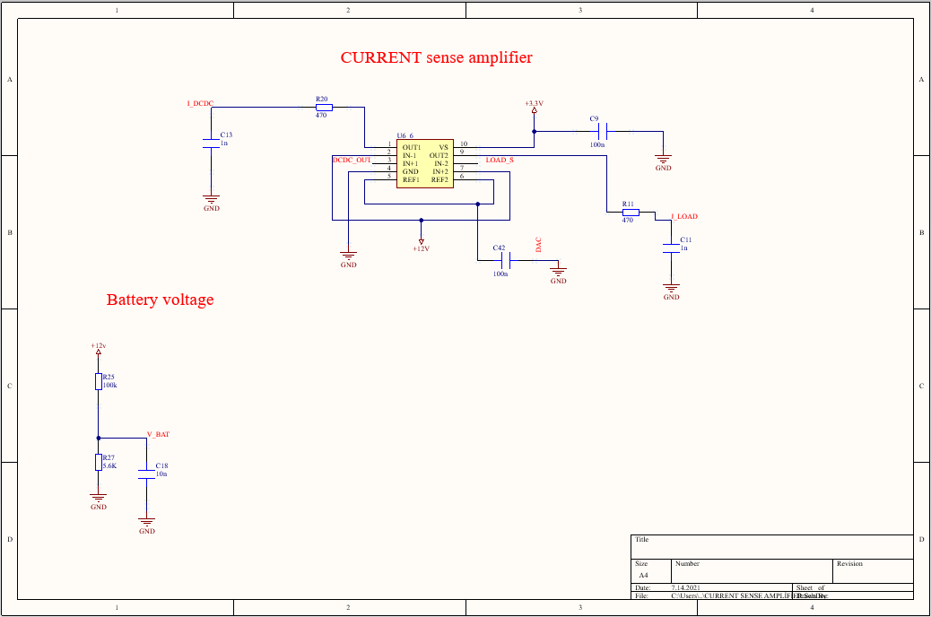

Figure 80: Current sense amplifier Schematic

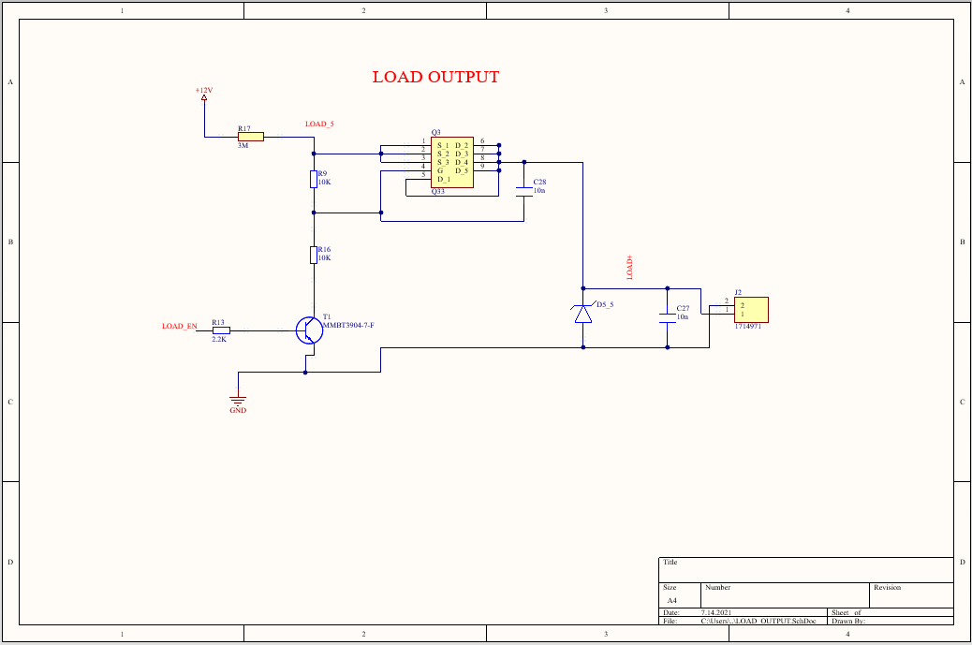

Figure 81: Load Output Schematic

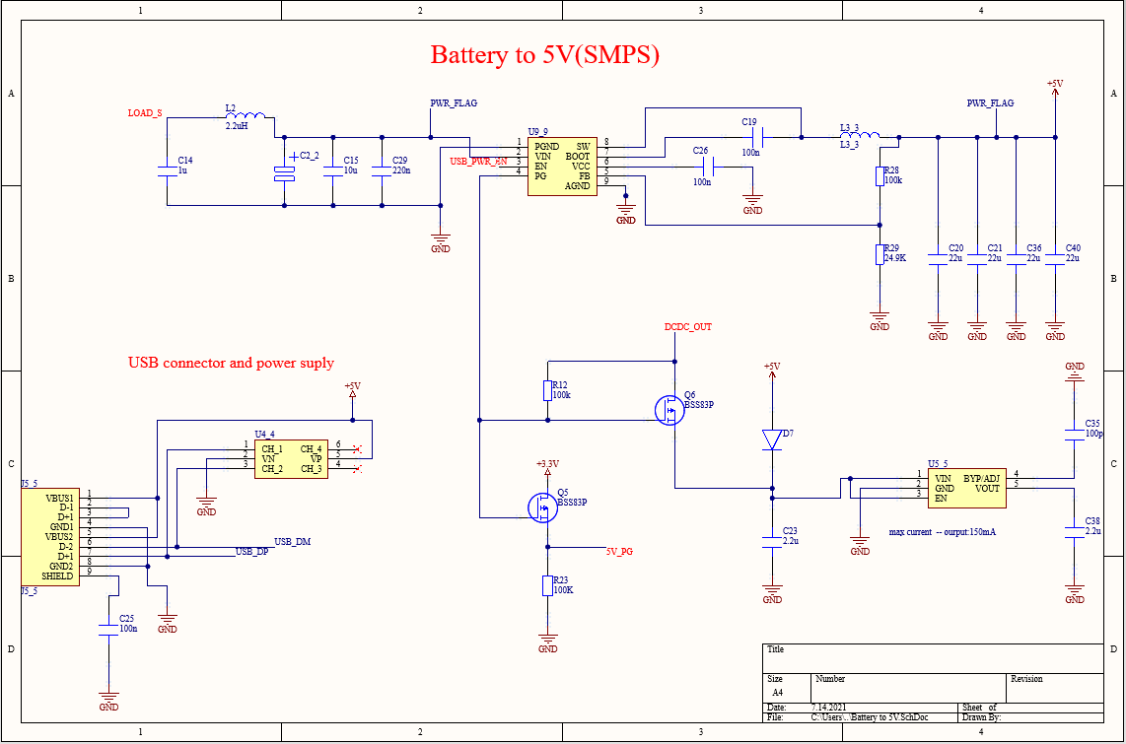

Figure 82: Battery to 5V(SMPS) Scheamtic

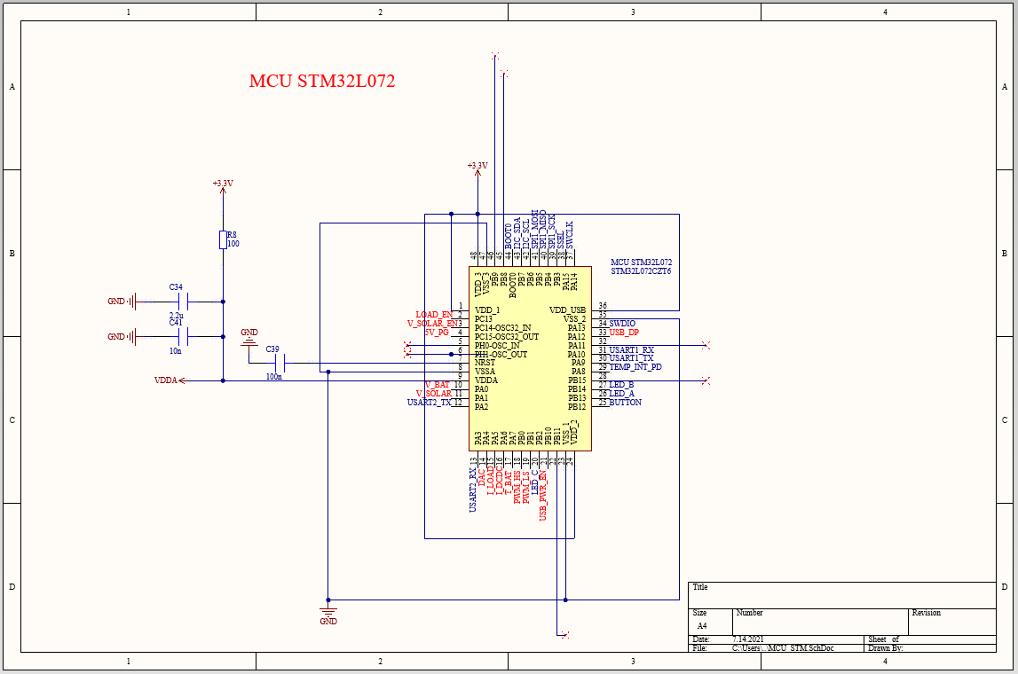

Figure 83: MCU STM32L072 Schematic

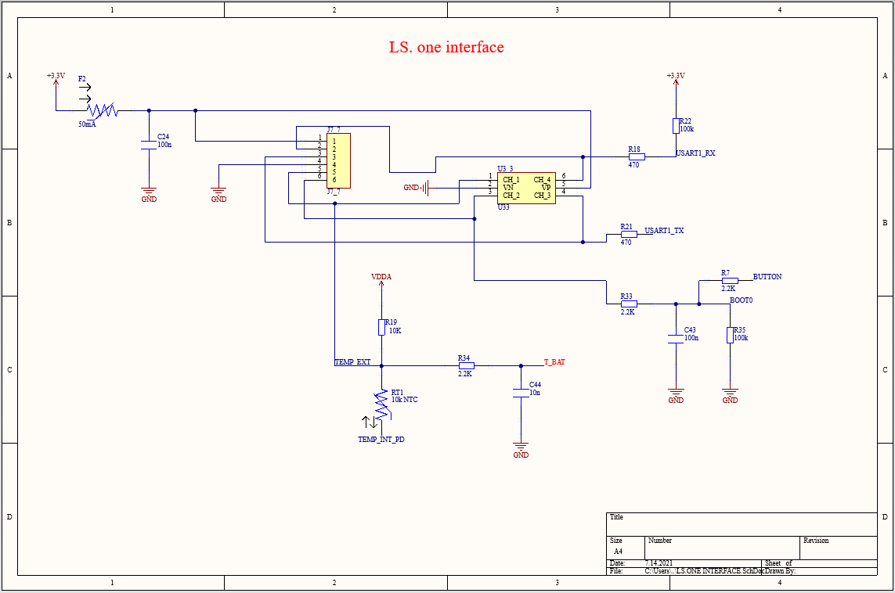

Figure 84: LS. One Interface Schematic

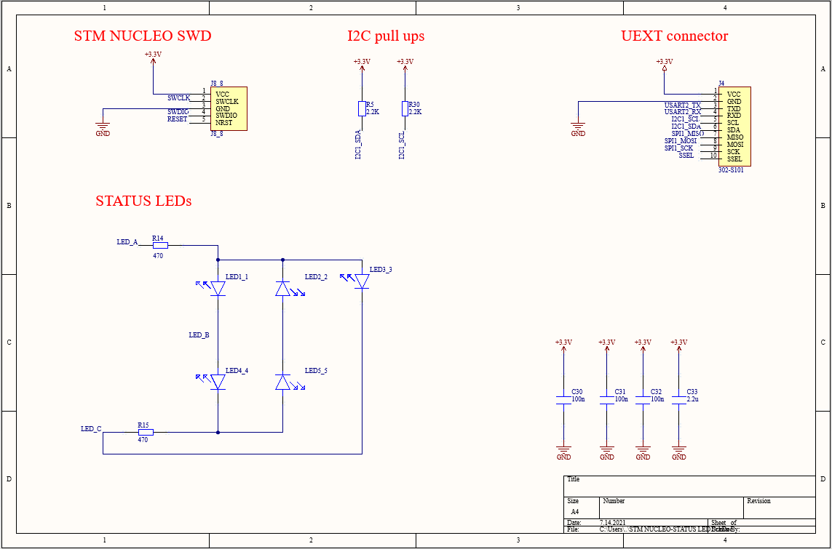

Figure 85: STM Nucleo SWD, I2C Pull Ups, UEXT Connector and Status LEDs Schematic

After creating each circuit diagram, we uploaded it to the PCB document. PCB is a circuit board with conductive paths on the circuit and the area outside these paths is an insulator. Here, we have implemented the physical placement on the PCB and electrically interconnected via paths, taking into account the libre solar MPPT-1210 charge control scheme.

While designing the PCB layout;

* Overall smooth layout of components and paths
* Components are accessible and easily visible
* Design for the suppression of Electromagnetic Noises
* Economics is taken into account.

**PCB Part:**

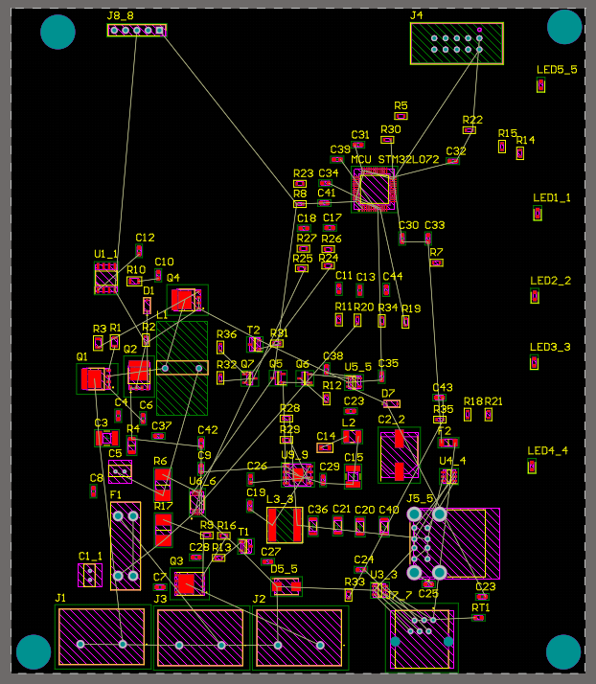

Figure 86: MPPT-1210 pcb design (2D model)

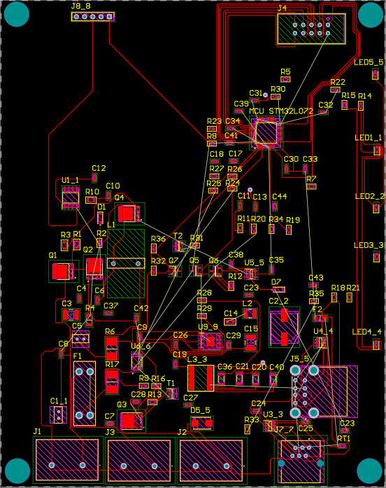

Figure 87: MPPT-1210 pcb design (2D model)

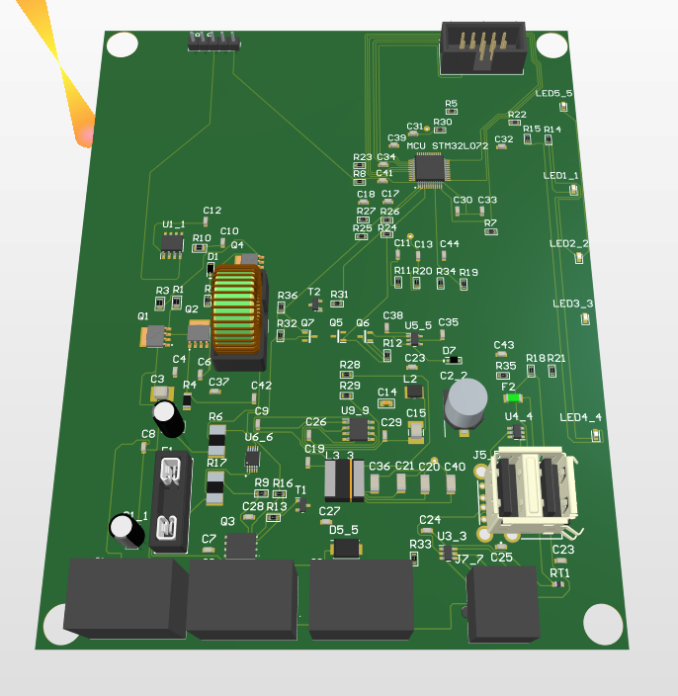

Figure 88: MPPT-1210 pcb design (3D model)

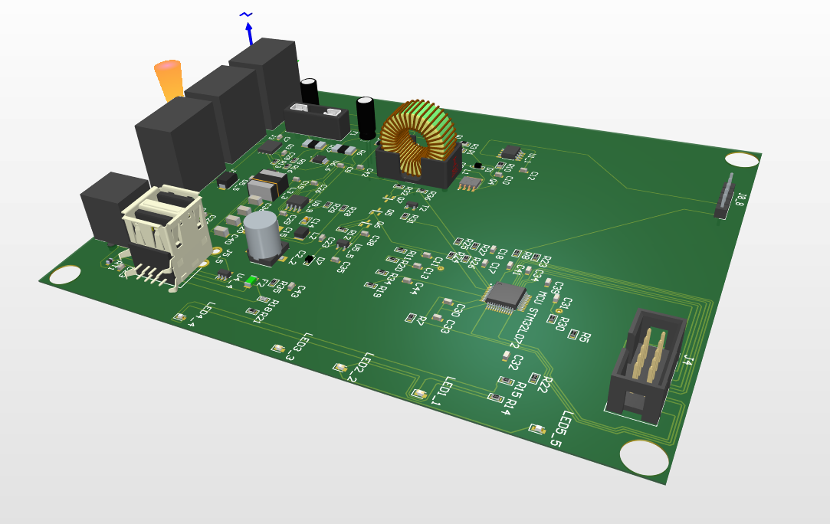

Figure 89: MPPT-1210 pcb design (3D model)

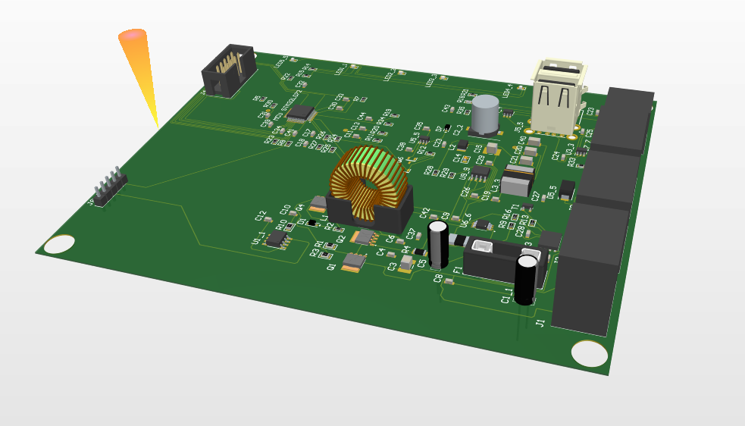

Figure 90: MPPT-1210 pcb design (3D model)

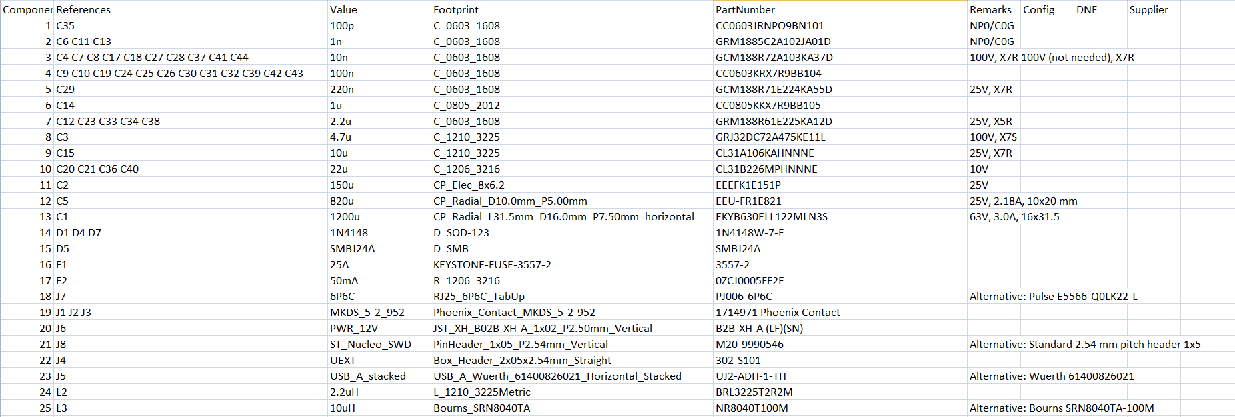

Figure 91: MPPT-1210 Bom[27]

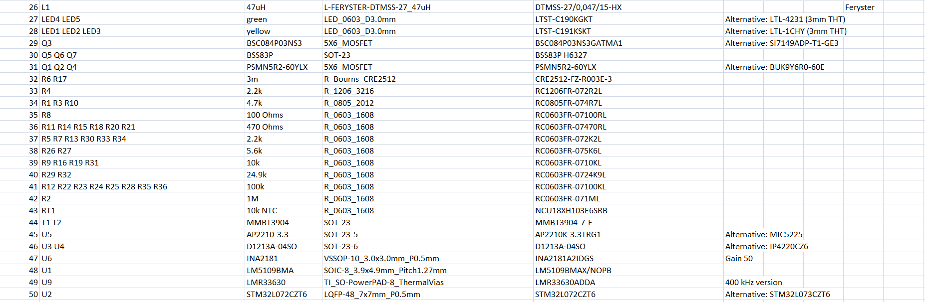

Figure 92: MPPT-1210 Bom [27]